Delphi Web Studio Capabilities and Publishing Reference
Google keys, website compatibility, comparisons, GitHub, credits, and future translation
Last changed: November 1, 2026
Based on the current application source and the official external references listed in this document.
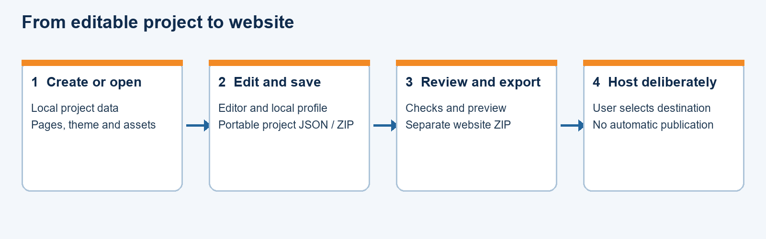
Figure 1. Local project work and the separate hosting decision.

Contents
4 Google Gemini key 3
5 Website and hosting compatibility 4
6 Comparison with Wix 4
7 Comparison with WordPress 4
8 GitHub website setup 4
9 GitHub push and publication 5
10 Authors and other credits 5
11 Future Delphi App Translation integration 5
Sources 6

4 Google Gemini key
A Gemini API key is optional. The app can create local starters and edit projects without a Google key. A key is used only for the optional cloud generation path, and sending a request requires the relevant session consent. Local AI is a different feature that uses separately selected local runtime and model files.
- Open Google AI Studio at https://aistudio.google.com/ and sign in. Accept the applicable terms. A new user may be given a default Cloud project and key; existing users may need to import an existing project.
- Open the API Keys page, select an appropriate project, and choose Create API key if a suitable key does not already exist. Copy the new key privately. If creation is unavailable, check project permissions and account eligibility in Google’s documentation.
- In Delphi Web Studio, open Settings, choose API Keys, enter the Gemini key, and enable cloud generation for the current session when you intend to use it. Use Test if desired. A successful key test establishes that the endpoint accepted that test; it does not guarantee model access, quota, billing, or successful generation.
- Review any prompt before sending it and review the generated content before accepting it. Do not include secrets or personal information unless you intend to send them to the service.
How long does the key last? Google does not give one universal lifetime for every key and policy. A key can be restricted, revoked, blocked, or otherwise stop working; check its current status in AI Studio. Google is moving Gemini access to authorization keys, so use a currently supported key and check Google’s latest guidance rather than relying on an old standard key.
Must it be re-entered? Newly entered keys and cloud consent are session-only in this app: after the app closes or reloads, enter the key and consent again for another session. This is an application storage behavior, not proof that Google issued a new key each time. An older key from a previous version may remain in local storage until removed using the available control.
Treat a key like a password. Keep it out of project files, exports, screenshots, and public repositories. If exposed, replace and revoke it through Google. Quotas, availability, and charges depend on the project, chosen service, and current Google terms.
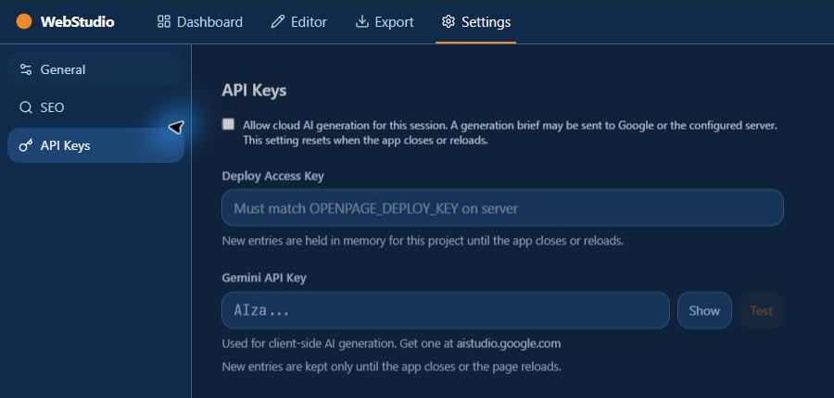
Figure 2. The API Keys settings screen.

5 Website and hosting compatibility
The application creates editable project files and can export static HTML or a website ZIP containing pages and assets. A compatible static host can serve the exported files when the expected paths and any subfolder settings are correct. Test the extracted result on a local web server and then on the intended host before making it public.
This is not a guarantee that the output can be dropped into any existing site or any site builder. Host restrictions, relative paths, custom domains, browser policies, external media, JavaScript modules, and server configuration affect behavior. Forms and newsletter features need an appropriate service; static hosting does not itself provide a form-processing server. Keep the project separately from the exported site.

6 Comparison with Wix
Both products offer visual website construction with reusable sections and page styling. Delphi Web Studio is a local experimental Windows editor that produces static files for an independently chosen compatible host. Wix is a hosted website platform with its own integrated editor, infrastructure, and service features.
They are not interchangeable project formats. Wix states that a Wix site relies on Wix infrastructure and must run on its servers for proper operation. Delphi Web Studio does not claim to open or faithfully reproduce an arbitrary Wix site. Wix includes hosted features outside the scope of this application; assess the specific features and costs that matter for a particular site.

7 Comparison with WordPress
Both can organize pages and article-like content. WordPress is a full content management system with themes and plugins, generally running on a web server. Delphi Web Studio edits a local project and produces static output; it is not a WordPress installation and does not run WordPress plugins, server-side PHP, accounts, or database features.
The app has a limited WordPress XML import for selected content. It is a conversion, not a theme or plugin migration. Review the report, pages, images, links, drafts, and retained source; keep the original WordPress export. The app does not currently export a complete WordPress theme or guarantee that a WordPress site can be recreated.

8 GitHub website setup
The current application does not automatically create a GitHub account, repository, GitHub Pages site, or required settings for a user or organization. A user or administrator must arrange the GitHub account, permissions, repository, and Pages configuration separately. GitHub’s documentation explains current eligibility and configuration; availability can depend on account plan and repository visibility.
The exported website can be placed in an appropriate GitHub Pages publishing source after the owner deliberately configures it. A project site may live under a repository subpath; set and test the site URL and paths accordingly. GitHub Pages serves static files and does not run server-side PHP, Ruby, or Python. Configuring or enabling a public site is a publication decision and has not been done for this project.

9 GitHub push and publication
The current local editor exports or reviews files; it does not automatically push a site to GitHub or automatically publish it to GitHub Pages. The GitHub link in the editor points to the application repository; it is not a setup or deployment wizard for the user’s site.
A user must take separate action to transfer the intended output into a configured repository. Once a GitHub Pages publishing source has been deliberately enabled, GitHub can automatically publish subsequent eligible pushes to that source; GitHub’s behavior is separate from this app. Review the destination and files before each push. Do not configure or publish a site until the owner explicitly wants that action.
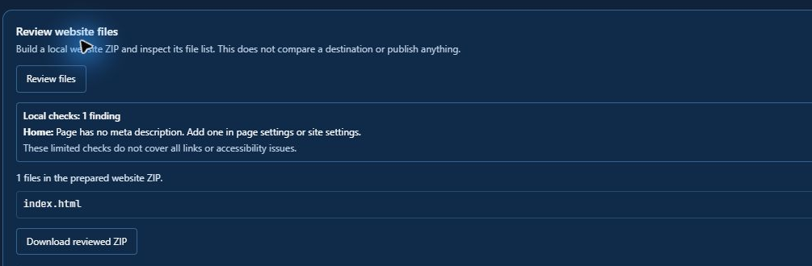
Figure 3. Local review is separate from upload and publication.

10 Authors and other credits
For an article, select a non-Home page, open Articles, mark it as an article, and enter the author and optional summary and tags. A ready article can show its author in the generated page and article index. A draft remains in the project but is excluded from the generated site until ready.
For site-wide credits, select the Footer component and use its Copyright field, description, or a normal content section or credits page. Enter names, permissions, image credits, and license notices as appropriate. These fields are user-authored text; the app does not automatically determine ownership or verify a license.

11 Future Delphi App Translation integration
A later integration is possible in principle, but it is not installed or verified here. Delphi Web Studio has two different user interfaces: a Delphi VCL host with designer-backed forms and dialogs, and a React/TypeScript editor displayed in WebView2. The separate Delphi App Translation Studio project has a Delphi-oriented runtime and form-scanning approach. It should be assessed against a copy of the VCL forms and Delphi strings first.
A practical plan is to inventory native form properties, menus, dialogs, and resourcestrings; scan the project with the translation tool; prepare and review language packs; add the designer-supported VCL manager and language selector where appropriate; and test switching, persistence, layout, accelerators, and placeholders. The other project’s documentation states that resourcestring entries may need explicit translation calls, so automatic coverage should not be assumed.
The React editor’s TypeScript strings and the content of exported websites need a separate localization approach and language resources. Translating the native shell alone will not translate the editor or a user’s website. Preserve product names and user content, test right-to-left layouts if supported, and evaluate version compatibility and licensing before integration. This is a future proposal, not work already performed.

Sources
Application evidence: src/routes/Settings.tsx; src/lib/generate-site.ts; src/routes/Deploy.tsx; src/lib/export-html.ts; src/editor/ArticlesPanel.tsx; desktop/DelphiWebStudio; and the User Guide. Future-translation assessment also reviewed the separate Delphi App Translation V2 project documentation and source layout.
Google Gemini API keys: https://ai.google.dev/gemini-api/docs/api-key
Google key troubleshooting: https://ai.google.dev/gemini-api/docs/troubleshooting
Google billing: https://ai.google.dev/gemini-api/docs/billing
GitHub Pages setup: https://docs.github.com/en/pages/getting-started-with-github-pages/creating-a-github-pages-site
Wix hosting and export: https://support.wix.com/en/article/can-i-host-a-wix-site-on
WordPress features: https://wordpress.org/about/features/
External services change; these references and this app’s implementation should be checked again before relying on a particular provider setup.

